**7th**

2019.8.27 Tsinghua University, Beijing

**Sino-German Symposium on Social Computing**



**SPONSOR**

Center for Network Research, Tsinghua University, Beijing

**ORGANIZER**

The Sino-German Institute of Social Computing

**SUPPORTING AGENCY**

Institute for Data Science, Tsinghua University, Beijing

The College of Technology，Tsinghua University, Hsinchu

**7th Sino-German Symposium on Social Computing**

Date: 2019.8.27 14:30-17:00

Site: Tsinghua University, Xiong Zhixing Building 211 Room

|  |  |
| --- | --- |
| Yang Chen | Fudan University |
| Xiaoming Fu | University of Gottingen |
| Krishna Gummadi | Max Planck Institute for Software Systems |
| Zhiyuan Liu | Tsinghua University, Beijing |
| Jarder Luo | Tsinghua University, Beijing |
| Alexander Mehler | University of Frankfurt |
| Tianguang Meng | Tsinghua University, Beijing |
| Christian Stegbauer | University of Frankfurt |
| Zhen Sun | Tsinghua University, Beijing |
| Juncheng Wang | Tsinghua University, Hsinchu |
| Yong Wang | Tsinghua University, Beijing |
| Yuezhi Zhou | Tsinghua University, Beijing |



The Tsinghua Center for Social Network Research was founded on Jan. 1st 2013. As a Tsinghua University research center, its purpose is to develop a platform for cooperation among physicists, computer scientists, and social, behavioral and epidemiology researchers, so that they can explore a set of interdisciplinary methodological approaches for studying complex social networks in big data.

Big data brings a lot of opportunities and challenges for interdisciplinary research: Various domains of knowledge have developed and accumulated a large body of hypotheses, models and empirical findings on the structure, dynamic processes, and consequences of social networks.

In order to arrive at a consensus we first need to create a methodological framework that takes data mining as its starting point. The object of research is online big data, which has the untapped potential to yield findings about new social phenomena. The next step is interpreting these findings through various qualitative and survey studies, which will further help us reveal grounded truth to verify theoretical hypotheses. The final step is building a model that encompasses the co-evolution of human actions and network structure based on the operative theories. With a model built on this solid foundation, researchers trained with interdisciplinary methods have the required information to predict new facts from their results.

Running in parallel to our research are real-world surveys that often generate new facts that conflict with our interpretation of the results of data mining. In this kind of scenario, we must return to our data and begin an iterative process of data mining, theory development and dynamic model building; until we can reconcile the two sets of results.

The goal of TCSNR is to develop a series of programs for training students with different research backgrounds, and mesh their different areas of expertise into a methodologically and substantively integrated whole. From this interdisciplinary training method we can expect new results and considerable progress in social network research.



The Sino-German Institute of Social Computing (SGISC) is an institute at Georg-August-Universität Göttingen, in close cooperation with the Sino-German Institute of Social Computing at Nanjing University, and the Center for Social Network Research at Tsinghua University, China.

The objective of Sino-German Institute of Social Computing (SGISC) is to lead the new research direction on social networks and big data through the cutting-edge ICT-enabled interdisciplinary research, promoting academic exchange and graduate training, as well as raising public awareness and joint research collaboration projects related to social computing.



The College of Technology Management, Tsinghua University (Hsinchu)

Founded in 2000, the College of Technology Management (CTM) is the first of its kind in Taiwan. Benefiting from Tsinghua University (Hsinchu)'s strength in science and engineering, CTM aims to integrate such strength with vigorous corporate connections and solid management curriculum and is widely recognized as a leading incubator for future leaders.

CTM is an interdisciplinary business school. As of 2018, CTM has more than 80 full-time faculty members, 2000 students and accumulated alumni 6000.

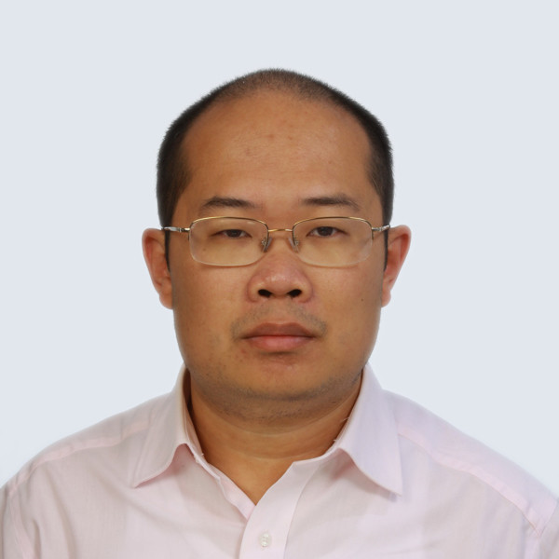 **Yang Chen**

**Associate Professor**

**School of Computer Science**

**Fudan University**

Yang Chen is an Associate Professor within the School of Computer Science at Fudan University. He received his B.S. and Ph.D. degrees from the Department of Electronic Engineering in Tsinghua University, in 2004 and 2009, respectively. He was a Postdoctoral Associate at the Department of Computer Science in Duke University, and was a Research Associate at the Institute of Computer Science of the University of Goettingen, Germany. His research interests include online social networks, Internet architecture and mobile computing. He is serving as an Editorial Board Member of the Transactions on Emerging Telecommunications Technologies (ETT) and IEEE Access. He served as an OC / TPC Member for several international conferences, including SOSP, WWW, IJCAI, AAAI, IWQoS and ICCCN. He published more than 60 referred papers in international journals and conferences, including IEEE TPDS, IEEE TMC, IEEE TSC, IEEE TNSM, IEEE TCSS, IEEE Communications Magazine, Middleware, INFOCOM, ICDCS, ICDE, CIKM, ACSAC and IWQoS.

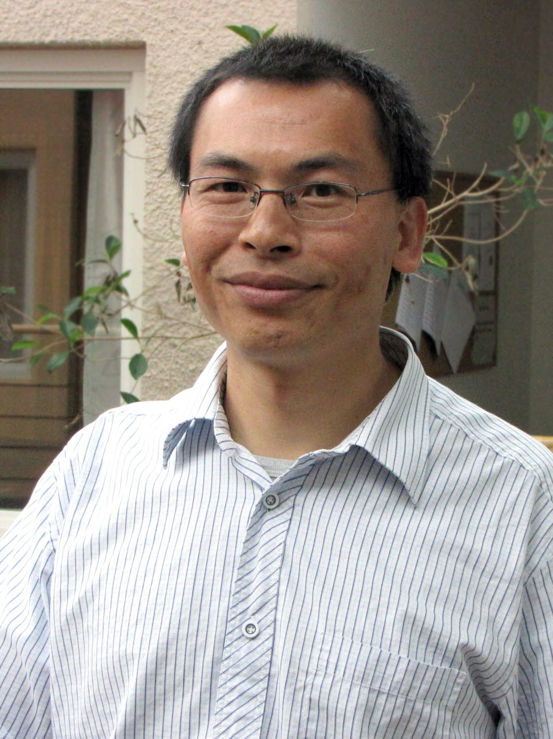 **Xiaoming Fu**

**Professor**

**Institute of Computer Science**

**University of Gottingen**

Xiaoming Fu received his Ph.D. from Tsinghua University and is currently Professor of Computer Science at University of Göttingen, Germany. He is interested in networked systems and services, cloud computing, mobile computing, big data and social networks. He has served on several journal editorial boards (e.g., IEEE Transactions on Network Science and Engineering, IEEE Transactions on Network and Service Management, IEEE Communications Magazine, Elsevier Computer Communications) and conference committees (e.g., SIGCOMM, MobiCom, CoNEXT, INFOCOM, ICNP, COSN), and as elected officers of IEEE Communications Society Technical Committees on Computer Communications (TCCC) and Internet (ITC). He is a fellow of Institution of Engineering and Technology (IET) and Academia Europaea (The Academy of Europe), an IEEE Senior Member and IEEE Distinguished Lecturer.

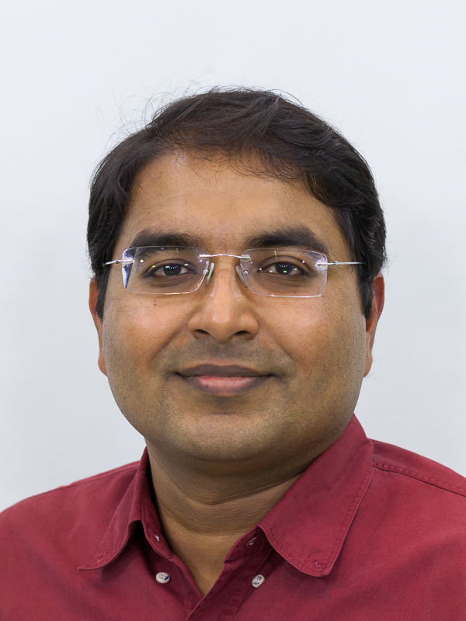  **Krishna Gummadi**

**Scientific Director**

**Max Planck Institute for Software Systems**

Krishna Gummadi is a scientific director and head of the Networked Systems research group at the Max Planck Institute for Software Systems (MPI-SWS) in Germany. He also holds an honorary professorship at the University of Saarland. He received his Ph.D. (2005) and B.Tech. (2000) degrees in Computer Science and Engineering from the University of Washington and the Indian Institute of Technology, Madras, respectively.

Krishna's research interests are in the measurement, analysis, design, and evaluation of complex Internet-scale systems. His current projects focus on understanding and building social computing systems. Specifically, they tackle the challenges associated with (i) assessing the credibility of information shared by anonymous online crowds, (ii) understanding and controlling privacy risks for users sharing data on online forums, (iii) understanding, predicting and influencing human behaviors on social media sites (e.g., viral information diffusion), and (iv) enhancing fairness and transparency of machine (data-driven) decision making in social computing systems.

Krishna's work on online social networks, Internet access networks, and peer-to-peer systems has been widely cited and his papers have received numerous awards, including SIGCOMM Test of Time, IW3C2 WWW Best Paper Honorable Mention, Runners-Up Casper Bowden Privacy Enhancing Technologies (PET) Award, and Best Papers at NIPS ML & Law Symposium, ACM COSN, ACM/Usenix SOUPS, AAAI ICWSM, Usenix OSDI, ACM SIGCOMM IMC, ACM SIGCOMM CCR, and SPIE MMCN. He has also co-chaired AAAI's ICWSM 2016, IW3C2 WWW 2015, ACM COSN 2014, and ACM IMC 2013 conferences. He received an ERC Advanced Grant in 2017 to investigate "Foundations for Fair Social Computing".

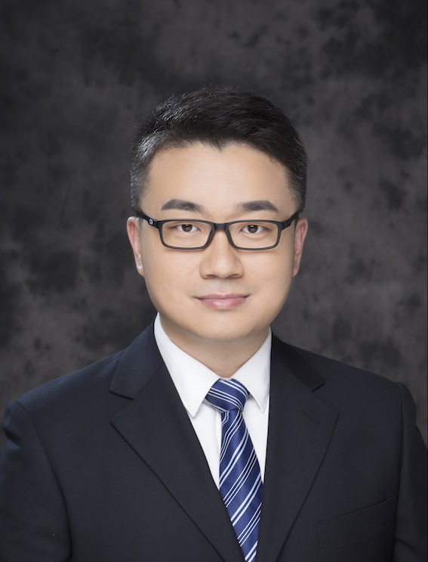 **Zhiyuan Liu**

**Associate Professor**

**NLP Lab**

**Department of Computer Science**

**Tsinghua University, Beijing**

Zhiyuan Liu is an associate professor at the Department of Computer Science and Technology, Tsinghua University. He received his Ph.D. degree in Computer Science from Tsinghua in 2011. His research interests include representation learning, knowledge graphs and social computation, and has published more than 80 papers in top-tier conferences and journals of AI and NLP including ACL, IJCAI and AAAI, cited by more than 5000 according to Google Scholar. He is the recipient of the Excellent Doctoral Dissertation of Tsinghua University, the Excellent Doctoral Dissertation of CAAI (Chinese Association for Artificial Intelligence).

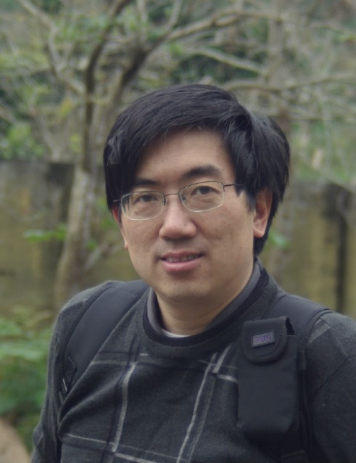 **Jar-Der Luo**

**Professor**

**School of** **Social Sciences & School of Public Policy and Management**

**Chairman of Tsinghua Social Network Research Center**

**Tsinghua University, Beijing**

Luo Jar-Der is a professor of Sociology Dept., Tsinghua University in Beijing, president of Chinese Network for Social Network Studies, and chairman of Tsinghua Social Network Research Center. He earned his Ph.D. degree in Sociology Dept. of State U. of New York at Stony Brook. He researches numerous topics in social network studies, including social capital, trust, social network analysis in big data, self-organization process and Chinese indigenous management researches, such as guanxi and guanxi circle.

Luo Jar-Der, with a group of voluntary network theorists, organized Chinese Network for Social Network Studies (in brief, CNSNS) in 2005. Its purposes aim at promoting Network Theories and Social Network Analysis in China and developing network theories suited for Chinese management. Chinese always describe themselves as a “Ren-Ching society”, that is, roughly saying, a society built upon social ties (guanxi) and favor exchanges (Ren-Ching- jiau-huan).

Luo Jar-Der organized Community Revitalization Research Center in Tsinghua U., which aims at doing experiments in communities and establishing a model for sustainable revitalization in urban and rural areas that emphasizes sustainability of the local ecology, economy, and social systems. We will endeavor to implement a revitalization model combining private-public partnership and sustainable concepts into practice, incorporating scientific planning, balanced development, step-by-step implementation and self-reliance of local community into our plan.

 **Alexander Mehler**

**Professor**

**Institute of Computer Science**

**University of Frankfurt**

Alexander Mehler is professor of Computational Humanities / Text-technology at Goethe University Frankfurt where he heads the Text Technology Lab (TTLab). He belonged to the executive committee of the German Society for Computational Linguistics & Language Technology where he currently heads the research group on Quantitative Corpus Linguistics. Alexander Mehler was head of the research group Computational Semiotics of the German Society of Semiotics and belonged to the executive committee of the LOEWE Priority Program "Digital Humanities". Currently, Alexander Mehler is member of the executive committee of the Center for Digital Research in the Humanities, Social Sciences and Education Sciences (CEDIFOR). Alexander Mehler is a founding member of the German Society for Network Research (DGNet). His research interests include the quantitative analysis, simulative synthesis and formal modelling of textual units in spoken and written communication. To this end, he investigates linguistic networks based on contemporary and historical languages (using models of language evolution). A current research interest of Alexander Mehler concerns 4D text technologies based on Virtual Reality (VR), Augmented Reality (AR) and Augmented Virtuality (AV).

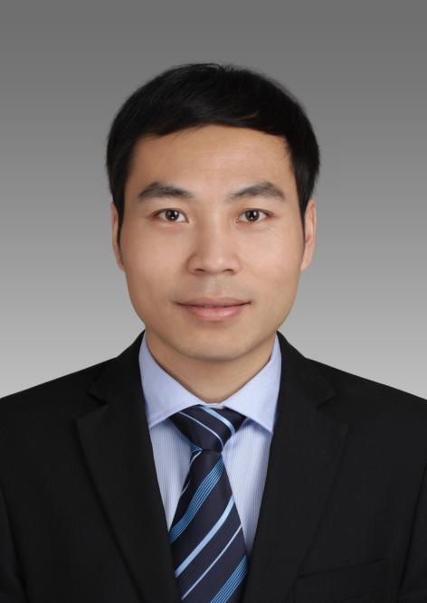  **Tianguang Meng**

**Associate Professor**

**Department of Political Science**

**Tsinghua University, Beijing**

Tianguang Meng is an associate professor in the Department of Political Science at the School of Social Sciences in Tsinghua University, the director of The Research Center on Data and Governance, and the executive director of Tsinghua Computational Social Science Institute. His research interest includes political institution, information and politics, Big data and governance, computational social science. He hosts both survey projects like China Urban Governance Survey (2015, 2018) and Chinese Public Official Survey (2013,2014,2015,2017, 2019), and several data science projects such as Government responsiveness in local China (2017), social media and anticorruption (2015), legal openness and judicial politics (2018), and online deliberation (2018). His articles have been published in Comparative Political Studies, Governance, Global Environmental Change, Social Science Research, Policy Study Journal, and International Journal of Public Opinion Research. He earned the B.A. and Ph.D. degrees in political science from Peking University. Previously, He was a visiting scholar in Harvard University and University of California, San Diego.

 **Christian Stegbauer**,

**Professor**

**Department of Sociology**

**Johann Wolfgang Goethe-University Frankfurt am Main**

Dr. Stegbauer is a professor in department of sociology, Johann Wolfgang Goethe-University Frankfurt am Main.

Dr. Stegbauer is Cofounder of the Online-Journal “kommunikation@gesellschaft”, Cofounder of the section for “Sociological Network Research” in the German Society of Sociology and also Cofounder and Chairperson of the German Society of Network Research. Fields of work are sociology of the internet, network research, sociology of culture and economic sociology.

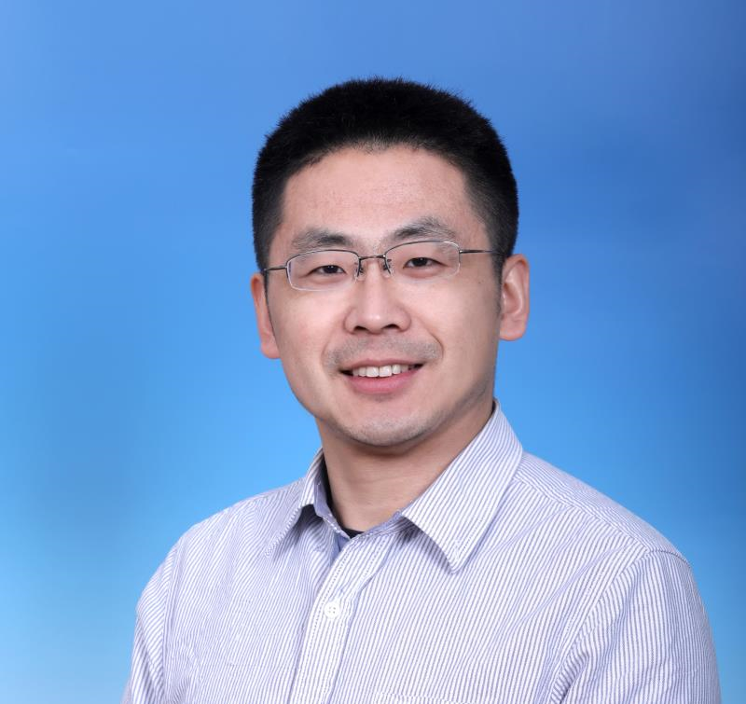 **Zhen Sun**

**assistant professor**

**School of Social Sciences**

**Tsinghua University, Beijing**

Zhen Sun is currently an assistant professor at the Institute of Economics, School of Social Sciences. His research focuses on innovation economics and the use of Intellectual Property system to promote innovation and economic growth. He has done research on Chinese patent policy and its implications, employing econometric techniques to probe the effects of differential local policies on local innovation. He has also worked on the patent citation data to disentangle the rich information embedded in the informational links to understand better the knowledge flow and value realization. He is also interested in internet economy and has done work with trading in online second-hand market, pricing in online market, etc. Zhen Sun has a PhD degree from the department of Agricultural and Resource Economics, University of California-Berkeley.

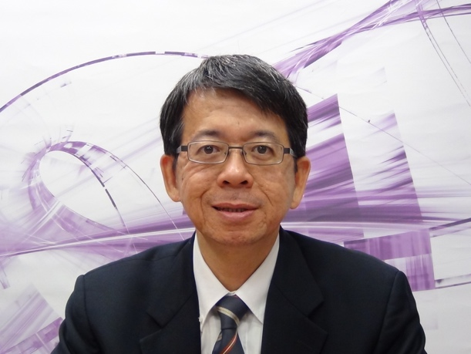 **Jyun-Cheng Wang**

**Professor**

**The College of Technology**

**Tsinghua University, Hsinchu**

Professor Jyun-Cheng Wang is the director of the Institute of Service Science at the College of Technology Management of Tsinghua University (Hsinchu). He is also the co-director of Center for Social Enterprise and Entrepreneurship at Tsinghua University (Hsinchu). He receives his Ph.D. of information management at the University of Wisconsin-Madison. His research interests include social network, online communities, digital innovation and e-commerce, social entrepreneur, and patent analysis. He has published several academic works in scholarly journals such as Electronic Commerce Research and Applications, Psychology and Marketing, Computers in Human Behavior, and Scientometrics. He is also one of the few authors who has published several business cases in Harvard Business Review. He is dedicated to bridging the industrious demands and emerging technologies into real-world applications in a newly TechTHY (Technology Taohuayuan) project.

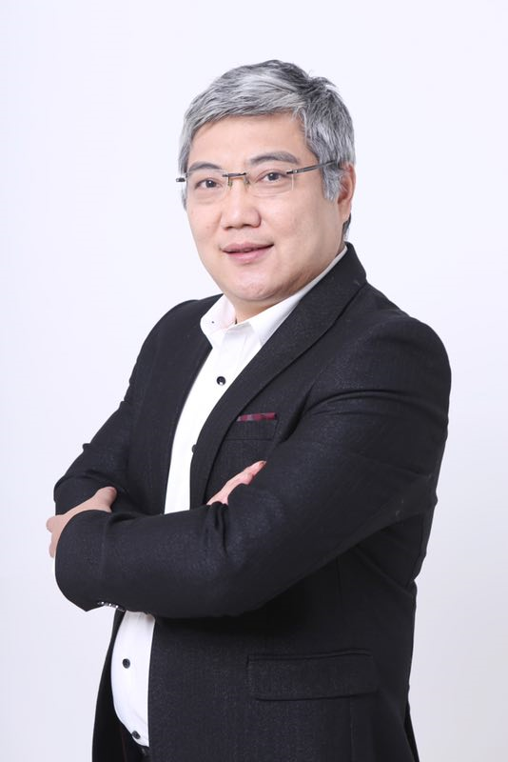  **Yong Wang**

**Associate Professor**

**School of Social Sciences**

**Tsinghua University, Beijing**

Dr Wang Yong is an associate professor at the Institute of Economics, School of Social Science, Tsinghua University, China. He also serves as the Deputy Director of the Institute of Economics, and the Executive Vice-President of the Institute of Minsheng Economic Research, Tsinghua University. He received his PhD degree at Peking University and finished the postdoctoral study at the Department of Economics, Harvard University. His research interests include Digital Economy, Industrial Organisation, and special economic zones (SEZs) in China and overseas.